FORLIANCE initiates, finances, creates and manages robust nature- based climate projects and integrates them into sustain-ability strategies with our clients to achieve their Net Zero Carbon targets. Together with our global partners, and our 50+ team members in ten countries, we strive to create intact forests and ecosystems that positively impact our climate, biodiversity and human well-being. We offer companies effective solutions for climate protection by developing individual climate protection strategies.

IT Administrator (m/w/d)

Join our Operations Division and help us deliver top-notch services and support to the entire FORLIANCE team! As part of our team, you'll get to shape and streamline our IT processes to cater to our expanding remote workforce. We're seeking a dynamic individual who's ready to make their mark and lead the charge towards IT excellence at FORLIANCE!

YOUR PROFILE:
- Completed technical university degree (preferably in computer science or information technology) or technical vocational training (e.g. IT specialist).
- Work experience as an IT administrator working with Microsoft 365.
- Advanced knowledge of cyber security best practices.
- Knowledge of AWS administration (an advantage)
- Knowledge of API and integration (an advantage)
- Strong service and customer orientation
- Solid interpersonal and inter-cultural skill-set with the ability to collaborate and positively influence diverse stakeholders
- Fluent English, excellent German skills, Spanish language skills would be advantageous.

YOUR TASKS:
- Administration of our M365 environment, including:
Sharepoint; Teams; Exchange Online; ADD; OneDrive;Microsoft Intune
- Working alongside our IT Service Provider to support our employees with their M365 and hardware-based issues.
- Administration of our cloud backup and antivirus services.
- Building out our IT policies.
- System monitoring of our SaaS-first cloud-based infrastructure.
- 3rd Level Support for our global team
- Support our development team in AWS administration.
- Initial set-up and ongoing maintenance of our team’s hardware.

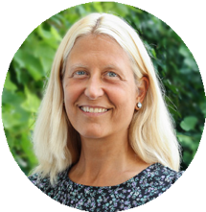
Uschi Dellian
Manager HR & Office
Be part of our excellent team and contribute to climate protection/ our mission. – This is a full-time position. Workplace in Germany, Spain or the Netherlands preferred. We look forward to receiving your application via e-mail to jobs@forliance.com.

WHAT WE OFFER:
● Collaboration in an international interdisciplinary and dynamic team
● Exciting field of work at the interface between business and climate protection
● A casual work environment with impact
● A comprehensive introduction to our team and processes while providing the space to develop your own
solutions – new ideas are expressly welcome
● Remote work possible if preferred
● Regular training and capacity building

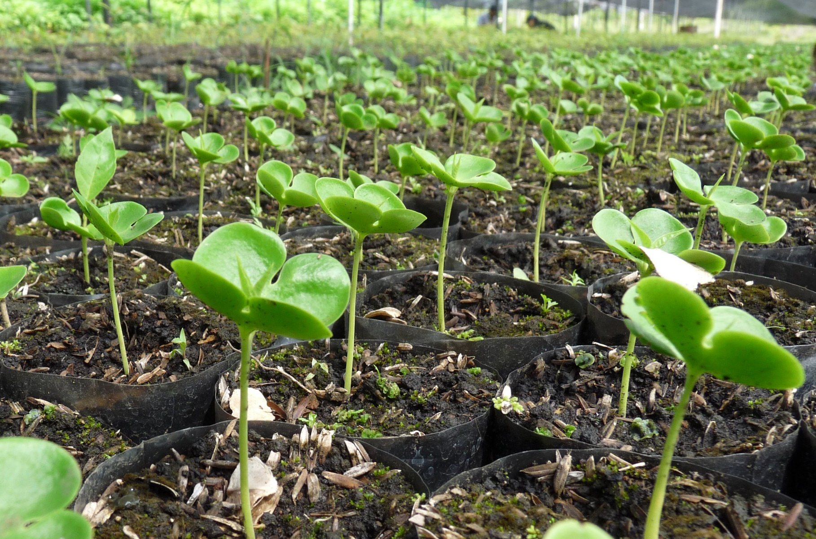
OUR MISSION:

WHAT WE OFFER:
- Collaboration in an international interdisciplinary and dynamic team
- Exciting field of work at the interface between business and climate protection
- A casual work environment with impact
- A comprehensive introduction to our team and processes while providing the space to develop your own solutions – new ideas are expressly welcome
- Remote work possible if preferred
- Regular training and capacity building
We let values GROW:
We create positive impact on our CLIMATE:
We take ACTION:

- we grow well financed, managed and monitored forests and ecosystems
- we grow long-term alliances with project stakeholders and clients
- we grow financial mechanisms and payment for ecosystem services to scale and improve projects
- we grow transparency and traceability through robust carbon standards, digital solutions, and earth observation technologies
- we grow the competency of our team by trainings, education and onboarding world leading experts
- we partner with implementation----- organizations, international investors and development banks to develop the most robust climate projects
- we help industry clients to account and manage their greenhouse emissions
- we monitor, report and verify impact and results of performance indicators
- we create climate solutions that are based on scientific research
- we initiate transformation to fight climate change and to achieve carbon targets.
- we mobilize finance for ecosystem services and develop new integrated value chains together with local stakeholders
- we use nature to build robust and proven carbon sinks by applying internationally recognized carbon standards and methodologies
- we turn carbon reduction plans into concrete action, and projects
- we think new ways and combine proven nature-based solutions with innovative financial mechanisms and state-of-the-art technology
- we unlock new climate action project types and promote developing of new methodologies for carbon sinks

